Imports System.Data.OleDb

Imports System.Data

Imports System.Configuration

Public Class empdatabasewithaccess

Dim dt As New DataTable

Dim conString As String = "Provider=Microsoft.ACE.OLEDB.12.0;Data Source=C:\Users\ktrim\Desktop\empdb.accdb"

Dim con As New OleDbConnection

Dim cmd As New OleDbCommand

Private Sub Emp_tableBindingNavigatorSaveItem_Click(sender As System.Object, e As System.EventArgs) Handles Emp_tableBindingNavigatorSaveItem.Click

Me.Validate()

Me.Emp_tableBindingSource.EndEdit()

Me.TableAdapterManager.UpdateAll(Me.EmpdbDataSet)

End Sub

Private Sub empdatabasewithaccess_Load(sender As System.Object, e As System.EventArgs) Handles MyBase.Load

Me.Emp_tableTableAdapter.Fill(Me.EmpdbDataSet.emp_table)

con.ConnectionString = conString

cmd.Connection = con

con.Open()

cmd.CommandText = "select * from emp_table"

Dim da As New OleDbDataAdapter(cmd)

da.Fill(dt)

con.Close()

End Sub

Private Sub btnadd_Click(sender As System.Object, e As System.EventArgs) Handles btnadd.Click

Emp_tableBindingSource.AddNew()

End Sub

Private Sub btnupdate_Click(sender As System.Object, e As System.EventArgs) Handles btnupdate.Click

Try

Emp_tableBindingSource.EndEdit()

Emp_tableTableAdapter.Update(EmpdbDataSet.emp_table)

MsgBox("data save")

Catch ex As Exception

MsgBox("error while comppile")

End Try

End Sub

Private Sub btndelete_Click(sender As System.Object, e As System.EventArgs) Handles btndelete.Click

Emp_tableBindingSource.RemoveCurrent()

End Sub

Private Sub txtsearch_TextChanged(sender As System.Object, e As System.EventArgs) Handles txtsearch.TextChanged

Dim dv As New DataView(dt)

dv.RowFilter = String.Format("name like '%{0}%'", txtsearch.Text)

DataGridView1.DataSource = dv

End Sub

End Class

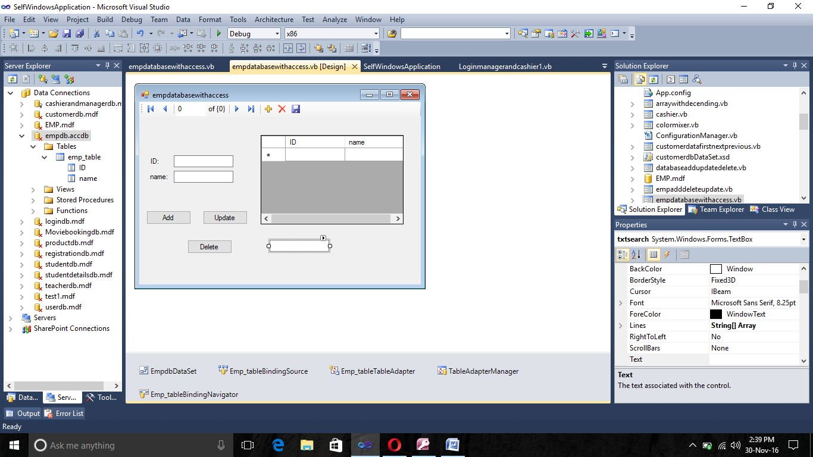

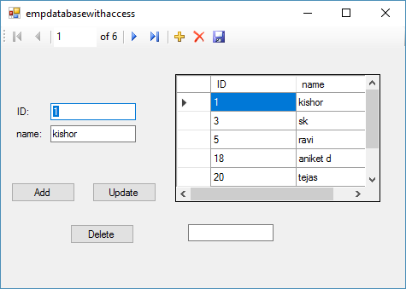

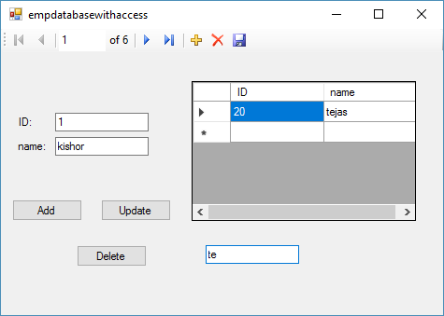

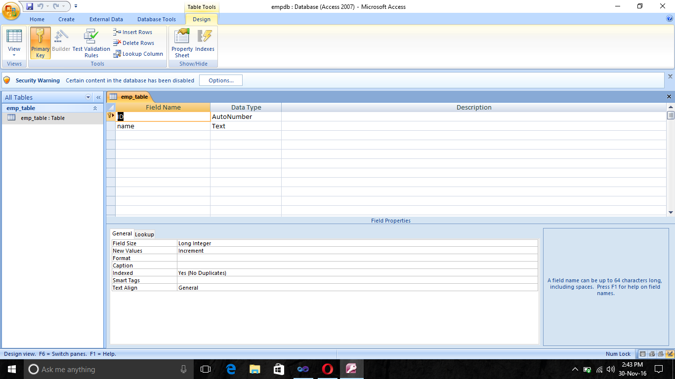

<Global.Microsoft.VisualBasic.CompilerServices.DesignerGenerated()> _

Partial Class empdatabasewithaccess

Inherits System.Windows.Forms.Form

'Form overrides dispose to clean up the component list.

<System.Diagnostics.DebuggerNonUserCode()> _

Protected Overrides Sub Dispose(ByVal disposing As Boolean)

Try

If disposing AndAlso components IsNot Nothing Then

components.Dispose()

End If

Finally

MyBase.Dispose(disposing)

End Try

End Sub

'Required by the Windows Form Designer

Private components As System.ComponentModel.IContainer

'NOTE: The following procedure is required by the Windows Form Designer

'It can be modified using the Windows Form Designer.

'Do not modify it using the code editor.

<System.Diagnostics.DebuggerStepThrough()> _

Private Sub InitializeComponent()

Me.components = New System.ComponentModel.Container()

Dim resources As System.ComponentModel.ComponentResourceManager = New System.ComponentModel.ComponentResourceManager(GetType(empdatabasewithaccess))

Dim IDLabel As System.Windows.Forms.Label

Dim NameLabel As System.Windows.Forms.Label

Me.EmpdbDataSet = New SelfWindowsApplication.empdbDataSet()

Me.Emp_tableBindingSource = New System.Windows.Forms.BindingSource(Me.components)

Me.Emp_tableTableAdapter = New SelfWindowsApplication.empdbDataSetTableAdapters.emp_tableTableAdapter()

Me.TableAdapterManager = New SelfWindowsApplication.empdbDataSetTableAdapters.TableAdapterManager()

Me.Emp_tableBindingNavigator = New System.Windows.Forms.BindingNavigator(Me.components)

Me.BindingNavigatorMoveFirstItem = New System.Windows.Forms.ToolStripButton()

Me.BindingNavigatorMovePreviousItem = New System.Windows.Forms.ToolStripButton()

Me.BindingNavigatorSeparator = New System.Windows.Forms.ToolStripSeparator()

Me.BindingNavigatorPositionItem = New System.Windows.Forms.ToolStripTextBox()

Me.BindingNavigatorCountItem = New System.Windows.Forms.ToolStripLabel()

Me.BindingNavigatorSeparator1 = New System.Windows.Forms.ToolStripSeparator()

Me.BindingNavigatorMoveNextItem = New System.Windows.Forms.ToolStripButton()

Me.BindingNavigatorMoveLastItem = New System.Windows.Forms.ToolStripButton()

Me.BindingNavigatorSeparator2 = New System.Windows.Forms.ToolStripSeparator()

Me.BindingNavigatorAddNewItem = New System.Windows.Forms.ToolStripButton()

Me.BindingNavigatorDeleteItem = New System.Windows.Forms.ToolStripButton()

Me.Emp_tableBindingNavigatorSaveItem = New System.Windows.Forms.ToolStripButton()

Me.IDTextBox = New System.Windows.Forms.TextBox()

Me.NameTextBox = New System.Windows.Forms.TextBox()

Me.DataGridView1 = New System.Windows.Forms.DataGridView()

Me.IDDataGridViewTextBoxColumn = New System.Windows.Forms.DataGridViewTextBoxColumn()

Me.NameDataGridViewTextBoxColumn = New System.Windows.Forms.DataGridViewTextBoxColumn()

Me.btnadd = New System.Windows.Forms.Button()

Me.btnupdate = New System.Windows.Forms.Button()

Me.btndelete = New System.Windows.Forms.Button()

Me.txtsearch = New System.Windows.Forms.TextBox()

IDLabel = New System.Windows.Forms.Label()

NameLabel = New System.Windows.Forms.Label()

CType(Me.EmpdbDataSet, System.ComponentModel.ISupportInitialize).BeginInit()

CType(Me.Emp_tableBindingSource, System.ComponentModel.ISupportInitialize).BeginInit()

CType(Me.Emp_tableBindingNavigator, System.ComponentModel.ISupportInitialize).BeginInit()

Me.Emp_tableBindingNavigator.SuspendLayout()

CType(Me.DataGridView1, System.ComponentModel.ISupportInitialize).BeginInit()

Me.SuspendLayout()

'

'EmpdbDataSet

'

Me.EmpdbDataSet.DataSetName = "empdbDataSet"

Me.EmpdbDataSet.SchemaSerializationMode = System.Data.SchemaSerializationMode.IncludeSchema

'

'Emp_tableBindingSource

'

Me.Emp_tableBindingSource.DataMember = "emp_table"

Me.Emp_tableBindingSource.DataSource = Me.EmpdbDataSet

'

'Emp_tableTableAdapter

'

Me.Emp_tableTableAdapter.ClearBeforeFill = True

'

'TableAdapterManager

'

Me.TableAdapterManager.BackupDataSetBeforeUpdate = False

Me.TableAdapterManager.emp_tableTableAdapter = Me.Emp_tableTableAdapter

Me.TableAdapterManager.UpdateOrder = SelfWindowsApplication.empdbDataSetTableAdapters.TableAdapterManager.UpdateOrderOption.InsertUpdateDelete

'

'Emp_tableBindingNavigator

'

Me.Emp_tableBindingNavigator.AddNewItem = Me.BindingNavigatorAddNewItem

Me.Emp_tableBindingNavigator.BindingSource = Me.Emp_tableBindingSource

Me.Emp_tableBindingNavigator.CountItem = Me.BindingNavigatorCountItem

Me.Emp_tableBindingNavigator.DeleteItem = Me.BindingNavigatorDeleteItem

Me.Emp_tableBindingNavigator.Items.AddRange(New System.Windows.Forms.ToolStripItem() {Me.BindingNavigatorMoveFirstItem, Me.BindingNavigatorMovePreviousItem, Me.BindingNavigatorSeparator, Me.BindingNavigatorPositionItem, Me.BindingNavigatorCountItem, Me.BindingNavigatorSeparator1, Me.BindingNavigatorMoveNextItem, Me.BindingNavigatorMoveLastItem, Me.BindingNavigatorSeparator2, Me.BindingNavigatorAddNewItem, Me.BindingNavigatorDeleteItem, Me.Emp_tableBindingNavigatorSaveItem})

Me.Emp_tableBindingNavigator.Location = New System.Drawing.Point(0, 0)

Me.Emp_tableBindingNavigator.MoveFirstItem = Me.BindingNavigatorMoveFirstItem

Me.Emp_tableBindingNavigator.MoveLastItem = Me.BindingNavigatorMoveLastItem

Me.Emp_tableBindingNavigator.MoveNextItem = Me.BindingNavigatorMoveNextItem

Me.Emp_tableBindingNavigator.MovePreviousItem = Me.BindingNavigatorMovePreviousItem

Me.Emp_tableBindingNavigator.Name = "Emp_tableBindingNavigator"

Me.Emp_tableBindingNavigator.PositionItem = Me.BindingNavigatorPositionItem

Me.Emp_tableBindingNavigator.Size = New System.Drawing.Size(473, 25)

Me.Emp_tableBindingNavigator.TabIndex = 0

Me.Emp_tableBindingNavigator.Text = "BindingNavigator1"

'

'BindingNavigatorMoveFirstItem

'

Me.BindingNavigatorMoveFirstItem.DisplayStyle = System.Windows.Forms.ToolStripItemDisplayStyle.Image

Me.BindingNavigatorMoveFirstItem.Image = CType(resources.GetObject("BindingNavigatorMoveFirstItem.Image"), System.Drawing.Image)

Me.BindingNavigatorMoveFirstItem.Name = "BindingNavigatorMoveFirstItem"

Me.BindingNavigatorMoveFirstItem.RightToLeftAutoMirrorImage = True

Me.BindingNavigatorMoveFirstItem.Size = New System.Drawing.Size(23, 22)

Me.BindingNavigatorMoveFirstItem.Text = "Move first"

'

'BindingNavigatorMovePreviousItem

'

Me.BindingNavigatorMovePreviousItem.DisplayStyle = System.Windows.Forms.ToolStripItemDisplayStyle.Image

Me.BindingNavigatorMovePreviousItem.Image = CType(resources.GetObject("BindingNavigatorMovePreviousItem.Image"), System.Drawing.Image)

Me.BindingNavigatorMovePreviousItem.Name = "BindingNavigatorMovePreviousItem"

Me.BindingNavigatorMovePreviousItem.RightToLeftAutoMirrorImage = True

Me.BindingNavigatorMovePreviousItem.Size = New System.Drawing.Size(23, 22)

Me.BindingNavigatorMovePreviousItem.Text = "Move previous"

'

'BindingNavigatorSeparator

'

Me.BindingNavigatorSeparator.Name = "BindingNavigatorSeparator"

Me.BindingNavigatorSeparator.Size = New System.Drawing.Size(6, 25)

'

'BindingNavigatorPositionItem

'

Me.BindingNavigatorPositionItem.AccessibleName = "Position"

Me.BindingNavigatorPositionItem.AutoSize = False

Me.BindingNavigatorPositionItem.Name = "BindingNavigatorPositionItem"

Me.BindingNavigatorPositionItem.Size = New System.Drawing.Size(50, 23)

Me.BindingNavigatorPositionItem.Text = "0"

Me.BindingNavigatorPositionItem.ToolTipText = "Current position"

'

'BindingNavigatorCountItem

'

Me.BindingNavigatorCountItem.Name = "BindingNavigatorCountItem"

Me.BindingNavigatorCountItem.Size = New System.Drawing.Size(35, 22)

Me.BindingNavigatorCountItem.Text = "of {0}"

Me.BindingNavigatorCountItem.ToolTipText = "Total number of items"

'

'BindingNavigatorSeparator1

'

Me.BindingNavigatorSeparator1.Name = "BindingNavigatorSeparator"

Me.BindingNavigatorSeparator1.Size = New System.Drawing.Size(6, 25)

'

'BindingNavigatorMoveNextItem

'

Me.BindingNavigatorMoveNextItem.DisplayStyle = System.Windows.Forms.ToolStripItemDisplayStyle.Image

Me.BindingNavigatorMoveNextItem.Image = CType(resources.GetObject("BindingNavigatorMoveNextItem.Image"), System.Drawing.Image)

Me.BindingNavigatorMoveNextItem.Name = "BindingNavigatorMoveNextItem"

Me.BindingNavigatorMoveNextItem.RightToLeftAutoMirrorImage = True

Me.BindingNavigatorMoveNextItem.Size = New System.Drawing.Size(23, 22)

Me.BindingNavigatorMoveNextItem.Text = "Move next"

'

'BindingNavigatorMoveLastItem

'

Me.BindingNavigatorMoveLastItem.DisplayStyle = System.Windows.Forms.ToolStripItemDisplayStyle.Image

Me.BindingNavigatorMoveLastItem.Image = CType(resources.GetObject("BindingNavigatorMoveLastItem.Image"), System.Drawing.Image)

Me.BindingNavigatorMoveLastItem.Name = "BindingNavigatorMoveLastItem"

Me.BindingNavigatorMoveLastItem.RightToLeftAutoMirrorImage = True

Me.BindingNavigatorMoveLastItem.Size = New System.Drawing.Size(23, 22)

Me.BindingNavigatorMoveLastItem.Text = "Move last"

'

'BindingNavigatorSeparator2

'

Me.BindingNavigatorSeparator2.Name = "BindingNavigatorSeparator"

Me.BindingNavigatorSeparator2.Size = New System.Drawing.Size(6, 25)

'

'BindingNavigatorAddNewItem

'

Me.BindingNavigatorAddNewItem.DisplayStyle = System.Windows.Forms.ToolStripItemDisplayStyle.Image

Me.BindingNavigatorAddNewItem.Image = CType(resources.GetObject("BindingNavigatorAddNewItem.Image"), System.Drawing.Image)

Me.BindingNavigatorAddNewItem.Name = "BindingNavigatorAddNewItem"

Me.BindingNavigatorAddNewItem.RightToLeftAutoMirrorImage = True

Me.BindingNavigatorAddNewItem.Size = New System.Drawing.Size(23, 22)

Me.BindingNavigatorAddNewItem.Text = "Add new"

'

'BindingNavigatorDeleteItem

'

Me.BindingNavigatorDeleteItem.DisplayStyle = System.Windows.Forms.ToolStripItemDisplayStyle.Image

Me.BindingNavigatorDeleteItem.Image = CType(resources.GetObject("BindingNavigatorDeleteItem.Image"), System.Drawing.Image)

Me.BindingNavigatorDeleteItem.Name = "BindingNavigatorDeleteItem"

Me.BindingNavigatorDeleteItem.RightToLeftAutoMirrorImage = True

Me.BindingNavigatorDeleteItem.Size = New System.Drawing.Size(23, 22)

Me.BindingNavigatorDeleteItem.Text = "Delete"

'

'Emp_tableBindingNavigatorSaveItem

'

Me.Emp_tableBindingNavigatorSaveItem.DisplayStyle = System.Windows.Forms.ToolStripItemDisplayStyle.Image

Me.Emp_tableBindingNavigatorSaveItem.Image = CType(resources.GetObject("Emp_tableBindingNavigatorSaveItem.Image"), System.Drawing.Image)

Me.Emp_tableBindingNavigatorSaveItem.Name = "Emp_tableBindingNavigatorSaveItem"

Me.Emp_tableBindingNavigatorSaveItem.Size = New System.Drawing.Size(23, 22)

Me.Emp_tableBindingNavigatorSaveItem.Text = "Save Data"

'

'IDLabel

'

IDLabel.AutoSize = True

IDLabel.Location = New System.Drawing.Point(16, 93)

IDLabel.Name = "IDLabel"

IDLabel.Size = New System.Drawing.Size(21, 13)

IDLabel.TabIndex = 1

IDLabel.Text = "ID:"

'

'IDTextBox

'

Me.IDTextBox.DataBindings.Add(New System.Windows.Forms.Binding("Text", Me.Emp_tableBindingSource, "ID", True))

Me.IDTextBox.Location = New System.Drawing.Point(58, 90)

Me.IDTextBox.Name = "IDTextBox"

Me.IDTextBox.Size = New System.Drawing.Size(100, 20)

Me.IDTextBox.TabIndex = 2

'

'NameLabel

'

NameLabel.AutoSize = True

NameLabel.Location = New System.Drawing.Point(16, 119)

NameLabel.Name = "NameLabel"

NameLabel.Size = New System.Drawing.Size(36, 13)

NameLabel.TabIndex = 3

NameLabel.Text = "name:"

'

'NameTextBox

'

Me.NameTextBox.DataBindings.Add(New System.Windows.Forms.Binding("Text", Me.Emp_tableBindingSource, "name", True))

Me.NameTextBox.Location = New System.Drawing.Point(58, 116)

Me.NameTextBox.Name = "NameTextBox"

Me.NameTextBox.Size = New System.Drawing.Size(100, 20)

Me.NameTextBox.TabIndex = 4

'

'DataGridView1

'

Me.DataGridView1.AutoGenerateColumns = False

Me.DataGridView1.ColumnHeadersHeightSizeMode = System.Windows.Forms.DataGridViewColumnHeadersHeightSizeMode.AutoSize

Me.DataGridView1.Columns.AddRange(New System.Windows.Forms.DataGridViewColumn() {Me.IDDataGridViewTextBoxColumn, Me.NameDataGridViewTextBoxColumn})

Me.DataGridView1.DataSource = Me.Emp_tableBindingSource

Me.DataGridView1.Location = New System.Drawing.Point(204, 56)

Me.DataGridView1.Name = "DataGridView1"

Me.DataGridView1.Size = New System.Drawing.Size(240, 150)

Me.DataGridView1.TabIndex = 5

'

'IDDataGridViewTextBoxColumn

'

Me.IDDataGridViewTextBoxColumn.DataPropertyName = "ID"

Me.IDDataGridViewTextBoxColumn.HeaderText = "ID"

Me.IDDataGridViewTextBoxColumn.Name = "IDDataGridViewTextBoxColumn"

'

'NameDataGridViewTextBoxColumn

'

Me.NameDataGridViewTextBoxColumn.DataPropertyName = "name"

Me.NameDataGridViewTextBoxColumn.HeaderText = "name"

Me.NameDataGridViewTextBoxColumn.Name = "NameDataGridViewTextBoxColumn"

'

'btnadd

'

Me.btnadd.Location = New System.Drawing.Point(12, 183)

Me.btnadd.Name = "btnadd"

Me.btnadd.Size = New System.Drawing.Size(75, 23)

Me.btnadd.TabIndex = 6

Me.btnadd.Text = "Add"

Me.btnadd.UseVisualStyleBackColor = True

'

'btnupdate

'

Me.btnupdate.Location = New System.Drawing.Point(107, 183)

Me.btnupdate.Name = "btnupdate"

Me.btnupdate.Size = New System.Drawing.Size(75, 23)

Me.btnupdate.TabIndex = 7

Me.btnupdate.Text = "Update"

Me.btnupdate.UseVisualStyleBackColor = True

'

'btndelete

'

Me.btndelete.Location = New System.Drawing.Point(81, 232)

Me.btndelete.Name = "btndelete"

Me.btndelete.Size = New System.Drawing.Size(75, 23)

Me.btndelete.TabIndex = 8

Me.btndelete.Text = "Delete"

Me.btndelete.UseVisualStyleBackColor = True

'

'txtsearch

'

Me.txtsearch.Location = New System.Drawing.Point(219, 232)

Me.txtsearch.Name = "txtsearch"

Me.txtsearch.Size = New System.Drawing.Size(100, 20)

Me.txtsearch.TabIndex = 9

'

'empdatabasewithaccess

'

Me.AutoScaleDimensions = New System.Drawing.SizeF(6.0!, 13.0!)

Me.AutoScaleMode = System.Windows.Forms.AutoScaleMode.Font

Me.ClientSize = New System.Drawing.Size(473, 307)

Me.Controls.Add(Me.txtsearch)

Me.Controls.Add(Me.btndelete)

Me.Controls.Add(Me.btnupdate)

Me.Controls.Add(Me.btnadd)

Me.Controls.Add(Me.DataGridView1)

Me.Controls.Add(IDLabel)

Me.Controls.Add(Me.IDTextBox)

Me.Controls.Add(NameLabel)

Me.Controls.Add(Me.NameTextBox)

Me.Controls.Add(Me.Emp_tableBindingNavigator)

Me.Name = "empdatabasewithaccess"

Me.Text = "empdatabasewithaccess"

CType(Me.EmpdbDataSet, System.ComponentModel.ISupportInitialize).EndInit()

CType(Me.Emp_tableBindingSource, System.ComponentModel.ISupportInitialize).EndInit()

CType(Me.Emp_tableBindingNavigator, System.ComponentModel.ISupportInitialize).EndInit()

Me.Emp_tableBindingNavigator.ResumeLayout(False)

Me.Emp_tableBindingNavigator.PerformLayout()

CType(Me.DataGridView1, System.ComponentModel.ISupportInitialize).EndInit()

Me.ResumeLayout(False)

Me.PerformLayout()

End Sub

Friend WithEvents EmpdbDataSet As SelfWindowsApplication.empdbDataSet

Friend WithEvents Emp_tableBindingSource As System.Windows.Forms.BindingSource

Friend WithEvents Emp_tableTableAdapter As SelfWindowsApplication.empdbDataSetTableAdapters.emp_tableTableAdapter

Friend WithEvents TableAdapterManager As SelfWindowsApplication.empdbDataSetTableAdapters.TableAdapterManager

Friend WithEvents Emp_tableBindingNavigator As System.Windows.Forms.BindingNavigator

Friend WithEvents BindingNavigatorAddNewItem As System.Windows.Forms.ToolStripButton

Friend WithEvents BindingNavigatorCountItem As System.Windows.Forms.ToolStripLabel

Friend WithEvents BindingNavigatorDeleteItem As System.Windows.Forms.ToolStripButton

Friend WithEvents BindingNavigatorMoveFirstItem As System.Windows.Forms.ToolStripButton

Friend WithEvents BindingNavigatorMovePreviousItem As System.Windows.Forms.ToolStripButton

Friend WithEvents BindingNavigatorSeparator As System.Windows.Forms.ToolStripSeparator

Friend WithEvents BindingNavigatorPositionItem As System.Windows.Forms.ToolStripTextBox

Friend WithEvents BindingNavigatorSeparator1 As System.Windows.Forms.ToolStripSeparator

Friend WithEvents BindingNavigatorMoveNextItem As System.Windows.Forms.ToolStripButton

Friend WithEvents BindingNavigatorMoveLastItem As System.Windows.Forms.ToolStripButton

Friend WithEvents BindingNavigatorSeparator2 As System.Windows.Forms.ToolStripSeparator

Friend WithEvents Emp_tableBindingNavigatorSaveItem As System.Windows.Forms.ToolStripButton

Friend WithEvents IDTextBox As System.Windows.Forms.TextBox

Friend WithEvents NameTextBox As System.Windows.Forms.TextBox

Friend WithEvents DataGridView1 As System.Windows.Forms.DataGridView

Friend WithEvents IDDataGridViewTextBoxColumn As System.Windows.Forms.DataGridViewTextBoxColumn

Friend WithEvents NameDataGridViewTextBoxColumn As System.Windows.Forms.DataGridViewTextBoxColumn

Friend WithEvents btnadd As System.Windows.Forms.Button

Friend WithEvents btnupdate As System.Windows.Forms.Button

Friend WithEvents btndelete As System.Windows.Forms.Button

Friend WithEvents txtsearch As System.Windows.Forms.TextBox

End Class